**FI – MM Integration**



Contents

Summary 3

Introduction 4

Important Terminologies 5

How the account determination attributes determined for each transaction key/event? 12

MM-FI Integration process Steps: 13

Conclusion 15

References 15

# Summary

This document explains “**The integration between FI & MM modules more specifically how an account is determined while posting stock related transactions”.**

# Introduction

Many of us find difficulties in understanding the concepts of MM-FI integration and account determination process. Let us try to understand how it’s been integrated and few terminologies used in MM-FI integration concepts.

How the GL account is picked automatically while posting stock related transactions?

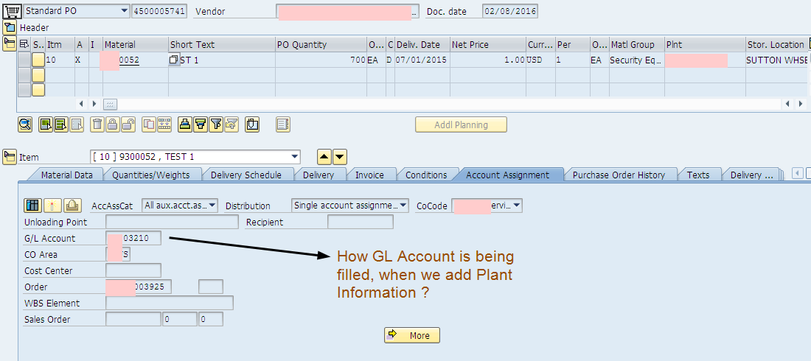

For this we just need to input plant, material, movement type and select the transaction we would like to check say GR for purchase order, GR for process order etc. Based on above inputs, system would read customization, master data and simulate the account determination process.

To achieve automatic GL Account determination, we should know few terminologies involved in the integration process.

# Important Terminologies

**Valuation area:**

Stock of a material owned by a company is an asset to the company. Valuation area defines the organization level at which materials are valuated.

SAP has provided two options for valuation.

1.     Valuation at plant level: All materials are valuated at plant level.

2.     Valuation at company code level: All materials in all plants of a company are valuated at company code level.

This setting is defined in t-code **OX14.**

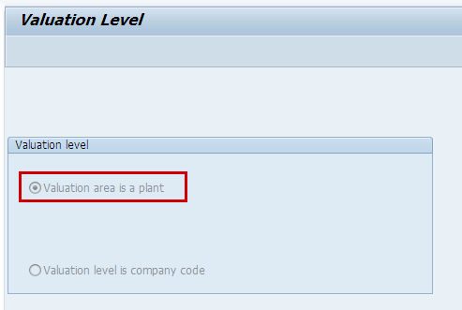

**Valuated stock:**

Total valuated stock = Stock in unrestricted use + Stock in transit between storage locations/warehouses of a plant + Stock in quality inspection.

**Material type:**

This defines the type of material.

EG: Raw material, finished goods etc.

Material type is defined during material master data creation.

**Movement type:**

This defines the type of material movement from one place to other. Movement type enables the system to find predefined posting rules determining how the stock and consumption accounts are to be posted. All possible goods movements are already defined by standard SAP

EG: Movement type 101 refers goods receipt

Movement type is entered while posting stock movement related transactions. Most of the time, standard SAP automatically derives the movement type based on transaction code.

 EG: If we go to MIGO, default movement type 101 is displayed by system.

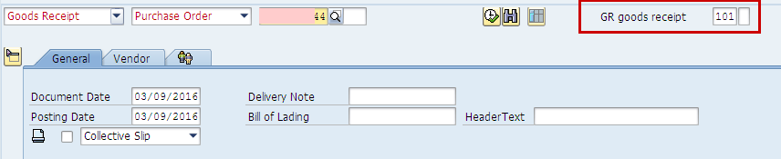

**Valuation class:**

Valuation class is defined for the combination of plant and material (In Accounting 1 view of material master).

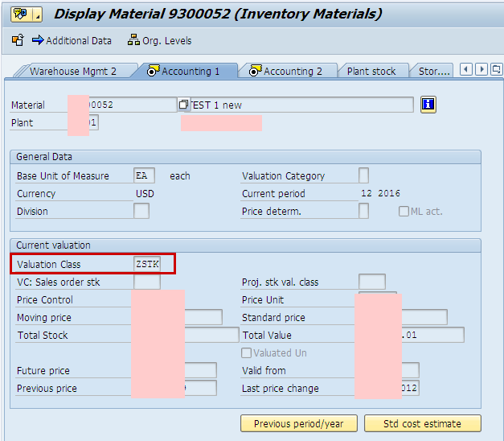

Valuation class allows posting of stock values of

1.     Materials of same material type to different G/L account (Different valuation class is assigned in different plants for the same material)

2.     Materials of different material type to same G/L account (Same valuation class is assigned to materials of different material type)

Note: G/L accounts can be defined at valuation class level along with other parameters.

**Valuation grouping code:**

Valuation grouping code combines the valuation areas having same business properties for the account determination. This reduces number of entries to be created for automatic account determination for the stock postings.

EG: Valuation area 1 and 2 are required to be posted to same G/L account, these are grouped to valuation grouping code ABC and G/L is determined based on valuation grouping code and valuation class.

Before using valuation grouping code, it needs to be activated in **OMWM.**

[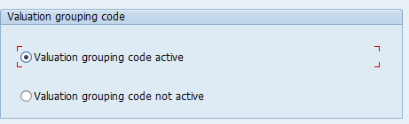](http://scn.sap.com/servlet/JiveServlet/showImage/38-106922-447615/z.png)

Valuation grouping code is assigned to valuation area in t-code **OMWD.**

In below example, five valuation areas are assigned to same valuation grouping code.

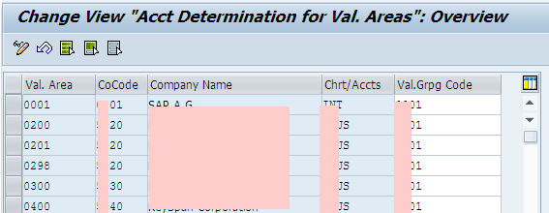

**Account modification/General modification:**

This key is used to determine different G/L account for the same kind of goods movement based on origin and target.

EG: During Goods issue, offsetting G/L is determined from transaction key GBB. If business wants to post to different G/Ls for goods issue for cost centers (Movement type 201) and good issues to orders (Movement type 261) for the same material and plant, Account modifier can help here. To understand this better, let us go to t-code **OMWN** where we define the transaction key and account modification for the movement type.

Transaction key which we see in **OBYC** is determined based on the movement type. In below screenshot, you can see all parameters are same for movement type 201 and 261 except account modification.

T-code **OMWN:**

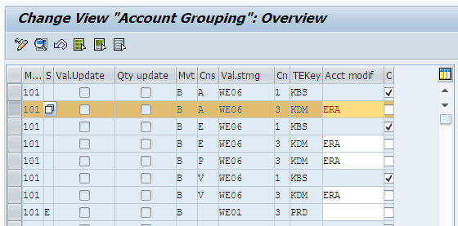

When material document is posted with these movement types, offsetting account is determined from transaction key GBB based on account modifier and valuation class.

From below screenshot, you can see that, different offsetting G/L account can be determined for the same transaction key and valuation class.

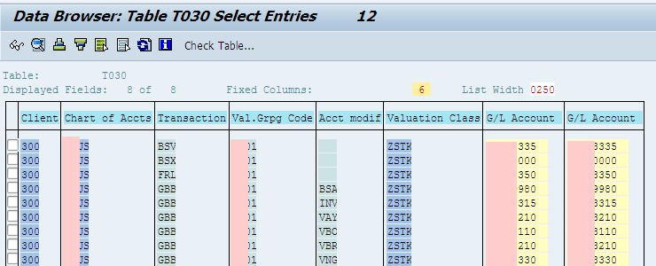

By Default, Standard SAP defines account modification keys for below transaction keys. User defined keys can also be defined and respective account determination settings can be maintained.

* GBB (offsetting entry for inventory posting)
* PRD (price differences)
* KON (consignment liabilities)

**Modifiers for GBB**

For the transaction/event GBB (offsetting entry for inventory posting), the following account groupings have already been assigned to the relevant movement types:

AUF: for goods receipts for production orders with account assignment

BSA: for initial entries of stock balances

INV: for expense/revenue from inventory differences

VAX: for goods issues for sales orders without account assignment object

VAY: for goods issues for sales orders with account assignment object

VBO: for consumption from stock of material provided to vendor

VBR: for internal goods issues (e.g., for cost center)

VKA: for consumption for sales order without SD

VNG: for scrapping/destruction

VQP: for sampling

ZOB: for goods receipts without purchase orders

ZOF: for goods receipts without production orders

**Modifiers for PRD**

If you also activate account grouping for transaction/event PRD (price differences) when you make the settings for automatic postings, the following account groupings are already assigned to the relevant movement types in the standard:

* none for goods receipts and invoice receipts for purchase orders
* PRF: for goods receipts for production orders
* PRA: for goods issues and other goods movements

**Modifiers for KON**

If you also activate account grouping for transaction/event KON (consignment liabilities) when you make the settings for automatic postings, the following account groupings are already assigned to the relevant movement types in the standard:

* none for consignment liabilities
* PIP: for pipeline liabilities

# How the account determination attributes determined for each transaction key/event?

Did you observe different set of fields appears for different transaction keys in OBYC while maintaining G/L account? Yes. This is defined in Rules for the transaction key.

EG: Select transaction key AUM in OBYC and click on "Rules" in toolbar.

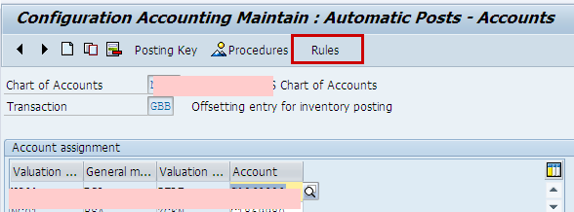

You can see that general modification and valuation modifier is active.

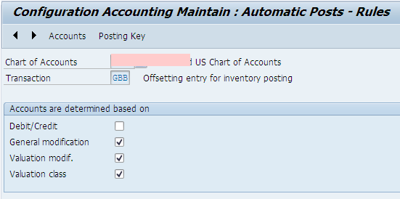

If you go to G/L account maintenance for this key, you would see the same fields.

# MM-FI Integration process Steps:

When we do material posting for a valuated material, below flow happens.

1. Movement type and other attributes like special stock indicator, movement indicator etc are determined based on business transaction like goods receipt for PO, production order etc.(OMWN). This is defined by standard SAP.

2. Transaction key/event and account modifier is identified based on movement type and other standard attributes in step 1 (OMWN)

3. Valuation grouping code activation is checked from OMWM

4. If active, for the given valuation area, valuation grouping code is identified from OMWD

5. For the identified transaction or event, check if valuation grouping code is active or not in OBYC (Click the rules button for the transaction key)

6. Valuation class is determined from material master.

7. Based on the above identified attributes, select the G/L account from OBYC.

If system can’t find any account for the found attributes, stock posting can’t be done and system through clear error stating for which combination of attributes, G/L account is missing. Such errors are mostly seen during go live/while posting to new materials due to missing G/L account maintenance or due to incorrect valuation class in material master data.

Account determination details are stored in table **T030**. If you want to know based on what details XXX account is determined, simply give that G/L in T030 table in field KONTS. This gives the possible combination of entries where this G/L is assigned. We can further drill down based on the filtered entries.

This configuration can also be done from SPRO as well.

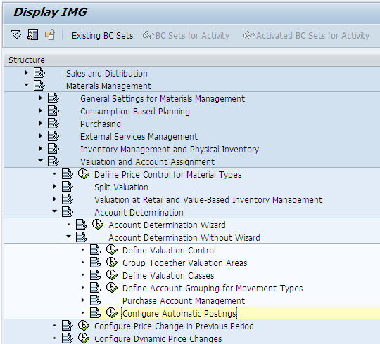

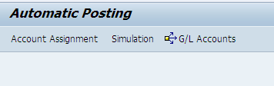

This in turn will route to the same Tcode which we discussed in the integration process above.

# Conclusion

By following the above process steps we can configure FI-MM integration and thereby achieve automatic GL account mapping.

# References

<https://scn.sap.com/thread/387599>

<https://sapfidocz.wordpress.com/2013/08/27/sap-fi-mm-integration/>